Virtual Food Drive - FAQs for Member Food Banks

- What’s the difference between a Virtual Food Drive vs. a donation form
- A Virtual Food Drive is much more than a place for someone to donate to a particular food bank. It is a platform that allows supporters to raise funds for their chosen food bank.
- In that way the reach is so much greater than that of the food bank directly. Everyone who creates a page to support their food bank can reach dozens or even hundreds of other individuals. Most of whom are not yet connected to the food bank themselves.
- Donors are motivated to give because of the personal relationship with the person asking for support. 1 in 4 people who are asked in this way do make a gift. That is a very high response.
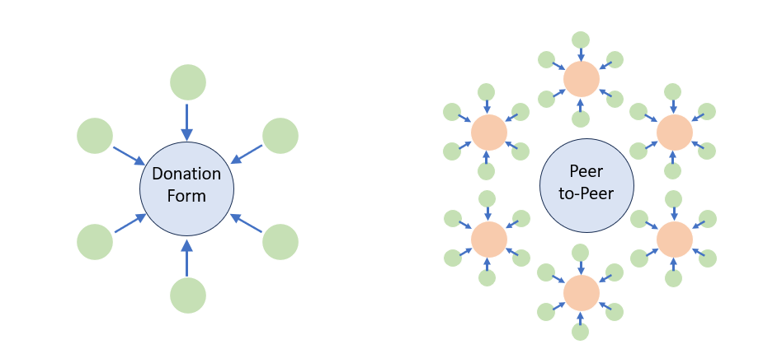
- The illustration below shows the power and reach of peer-to-peer vs just asking for donations, the green indicating donors. 6 people will make a donation or, if they become fundraisers on the platform, they attract (at an absolute minimum, as an example) 36 donors.
6 fundraisers and many donations
(apologies for reminding you of chemistry class)
6 donors making 6 donations

- How can you promote this concept to my community?
- We have created a document with some great tips here: https://bcvfd.foodbank.bc.ca/promotion Click the top link on that page.
- By far the best way to drive registrations to support your food bank is through your own donors, supporters, volunteers and community at large.
- There are also 3 email templates on that page that you can edit and modify to your needs so you can send out and invite recipients to participate.
- Feel free to reach out to discuss ideas. Each community is unique and we recognize that. Contact andrep@foodbank.bc.ca to talk.
- You know your community best. Tap into promotional channels that work for you.
- Many people still want to do traditional food drives. How can I convince them otherwise?
- Supporters always want to do what is best, but they may not realize that a food drive might not be the best way to support their local food bank. It’s a matter of education. Given good reasons why you prefer financial donations over food drives, most people will realize that financial donations will have a much greater impact.
- There is a good document here – “Why a Virtual Food Drive?” – that can help with this discussion: https://bcvfd.foodbank.bc.ca/Resources Not all examples will apply to you. Please tailor it to your specific situation.
- Is it available throughout the year?
- This pilot is a term of 1 year based on the platform license. It is available until next August but the majority (75 - 80%) of fundraising opportunity will be October – December so that is the time to drive maximum attention to the platform through marketing and promotion.

- Do I have to pay for it?
- There is no upfront cost or cost to participate to any member.
- Revenue raised for any member is net new revenue
- The only costs / expenses of the project will come out of the revenue received. These include:
    - credit card and processing fees – same as for a donation through almost any processing gateway, in this case Stripe at 2.2% + 30 cents per transx (3.5% for Amex)
    - small recuperation of costs for FBBC for staff and marketing support
    - FBBC is paying for the platform license.

- Who receipts the donation?
- FBBC issues the tax receipt through the platform as donations go through FBBC’s Stripe and bank account.
- Receipts adhere to CRA’s requirements
- We are looking at having the specific food bank to which the donation is made added to the tax receipt.
- Can food banks customize the thank you email?
- At this point that is not possible. There is only one email template available for all donations through the platform.
- Variable content can be added to the letter, including donor name, gift amount, etc.
- Will I have access to donor information for stewardship after the holiday season?
- Yes, you can receive a list of donors in January once activity slows down.
- We encourage you to contact your donors to thank and steward them.
- We will also do our best to notify you of any large gifts to your food bank. A simple thank you to a donor goes a long way towards building a direct relationship and potentially another gift from that donor.

- Can food banks moderate donor fundraisers? (ie. a VFD contains incorrect information etc.)
- Individual food banks cannot access pages to make any changes.
- If there is content on a page that needs to be removed or changed, please contact andrep@foodbank.bc.ca
- How are funds transferred to specific food banks? How frequently?
- FBBC will direct all funds to designated food banks in January. If you’re needing the funds prior to that time, please be in touch with Nick: nick@foodbanksbc.com

- Is there a way to donate multiple times but receive just one receipt?
- Each donation receives its own receipt. Currently monthly donations are not available through the site.

- Are there any expectations to use this platform exclusively vs having peer to peer pages on other sites?
- There are no expectations that you must use or promote this site exclusively.

- Do we have to set up an account to receive funds?
- There is no requirement to register or set up an account to receive funds. A marketing campaign will be conducted to drive traffic and registrations. As mentioned above, the more you can do to promote the VFD, the more you should stand to raise for your food bank.

- Do the funds procured through this platform need to be spent on food?
- There are no restrictions as to how funds can be used.

